Chapter 1. Introduction:

1. What are the Internet and the WWW?
The Internet is a network of networks.
The WWW is a distributed system that runs on the top of the Internet.

2. Types of Networks. (Section 1.2)
Personal Area Networks
Local Area Networks
Metropolitan Area Netwroks
Internetworks
Wide Area Networks

3. Network Hierarchies (Section 1.3.1)
To reduce their design complexity, most networks are organized as a stack of layers or levels, each one built upon the one below it. The purpose of each layer is to offer certain services to the higher layers while shielding those layers from details of how the offered services are actually implemented.
A protocol is an agreement between the communicating parties on how communication is to proceed.
Between each pair of adjacent layers is an interface. The interface defines which primitive operations and services the lower layer makes available to the upper one.

4. Layers, protocols and Interfaces (Section 1.4)
Seven layers of OSI (from up to bottom): Application, Presentation, Session, Transport, Network, Data Link, Physical
Four layers of TCP/IP (from up to bottom): Application, Transport, Internet, Link
Five layers used in book: Application, Transport, Network, Link, Physical

DIFFERENCES Between OSI and TCP/IP
The biggest contribution of the OSI model is that it makes the distinction between the three concepts of Services, Interfaces and Protocols explicit.
Each layer performs some services for the layer above it.
A layer's interface tells the processes above it how to access it.
The peer protocols used in a layer are the layer's own business.

The TCP/IP model did not originally clearly distinguish between Services, Interfaces and Protocols (although people have tried to retrofit it after the fact to make it mroe OSI-like).

OSI model supports both connectionless and connection-oriented communication in the network layer, but only connection-oriented communication in the transport layer. TCP/IP model supports only connectionless in the network layer but both in the transport layer.

CO and CL
Connection-oriented service is modeled after the telephone system. To use a connection-oriented network service, the service user first establishes a connection, uses the connection, and then releases the connection. In some cases when a connection is established, the sender, receiver and subnet conduct a negotiation about the parameters to be used.
Connectionless service is modeled after the postal system. Each packet carries the full destination address, and each one is routed through the intermediate nodes inside the system independent of all subsequent messages. When the intermediate nodes receive a message in full before sending it on to the next node, this is called store-and-forward switching. The alternative, in which the onward transmission of a message at a node starts before it is completely received by the node, is called cut-through switching.

5. Service Primitives (1.3.3,1.3.4,1.3.5)
CO & CL: check the previous question.

A service is formally specified by a set of primitives (operations) available to user processes to access the service. If the protocol stack is located in the operating system, the primitives are normally system calls.

Primitives in Berkeley socket interface: LISTEN, CONNECT, ACCEPT, RECEIVE, SEND, DISCONNECT.

DIFFERENCES BETWEEN SERVICE AND PROTOCOL
A service is a set of primitives (operations) that a layer provides to the layer above it. A protocol, in contrast, is a set of rules governing the format and meaning of the packets, or messages that are exchanged by the peer entities within a layer.
A service is like an abstract data type or an object but does not specify how these operations are implemented. In contract, a protocol relates to the implementation of the service and as such is not visible to the user of the service.

6. Network Reference Models (TCP/IP and OSI Reference) (1.4.1,1.4.2 and 1.4.3)
Example Question:

Briefly explain the design principles and benefits of the Open Systems Interconnection (OSI) Layer Division approach (and layered approaches in general) for network design.

Benefits of OSI = Layer design + distinction of three concepts of OSI, check No.4 question of the chapter.

Chapter 2. The Physical Layer:

We will mainly focusing on bandwidth and delay in this topic.

1. Nyquist theorem (2.1.3)
Baud rate and bit rate.

We call the rate at which the signal changes the symbol rate to distinguish it from the bit rate. The bit rate is the symbol rate multiplied by the number of bits per symbol. An older name for the symbol rate is the baud rate.

Latency or delay
Latency is the time delay associated with sending a message over a link.

2. Guided media- Copper vs Fibre (2.2.3 and 2.2.4).
Copper: cheaper, no specialist skills required
Fibre: higher bandwidths, greater distance between repeaters (5km vs. 50km), not physically influenced by interferences or surges, thin/lightweight, no leakage, difficult to tap

Chapter 3. The Data Link layer

1. Design Issues (3.1)
Units, Services, Framing

FUNCTIONS OF DATA LINK LAYER
a. Providing a well-defined service interface to the network layer.
b. Dealing with transmission errors.
c. Regulating the flow of data so that slow receivers are not swamped by fast senders.

2. Framing (3.1.2)
To make it easy for a receiver to find the start of new frames while using little of the channel bandwidth:
a. Byte/Character count
b. Flag bytes with byte stuffing
c. Flag bits with bit stuffing
d. Physical layer coding violations

3. Flow Control and Error control (3.1.3 and 3.1.4)
Flow control:
a. Feedback control
b. Rate based

Error correcting:
a. Hamming code
b. Binary convolutional codes
c. Reed-Solomon codes
d. Low-Density Parity Check code

Hamming code:
a. n = m + r
b. d+1 (detecting) 2d+1 (correcting)
c. correct one => =>

Error detecting:
a. Parity
b. Checksum, e.g., 16-bit internet in IP, Flectcher's checksum
c. CRC

4. Flow control protocols: Stop and Wait, Go-back N and Selective repeat.
 | Utilization | Pros | Cons
Stop and Wait | 50%
One Bit | 100% |  | Synchronization issues
Go-Back-N | 100% | Senders do not need to wait for ack before sending next | Receiver discards all subsequent frames from error point, sending no ack, until the next frame in sequence
Selective Repeat | 100% | Cumlative ack  NAK | Receiver needs more buffer

LINK UTILIZATION FORMULA
B: the bit-rate of the link (unit: bit/sec)
L: length of the frame (unit: bit)

(unit: sec)
(assume this is zero)

Chapter 4. The MAC sub Layer (Updated)

1. Multiple access protocols (4.2)
a. ALOHA (pure/slotted)
b. CSMA (Carrier Sense Multiple Access)
c. Collision Free
d. Limited Contention
e. Wireless LAN protocols

2. CSMA (4.2.2)
Require state detection to determine transmission rights dynamically.

a. Persistent and Non-Persistent CSMA
1-persistent CSMA, Non-Persistent CSMA, p-persistent CSMA
b. CSMA/CD (CSMA with Collision Detection)
Principle that transmission aborted when collision detected
After collision detected, abort, wait random period, try again
Channel must be continually monitored, implies only half-duplex system

DIFFERENCES (Summarized from last line, P266 & 4th line, last paragraph, P268)
 | Collision during transmission
CSMA | Transmit a whole frame anyway, react to collisions after the transmission is over
CSMA/CD | Abort the transmission when collides

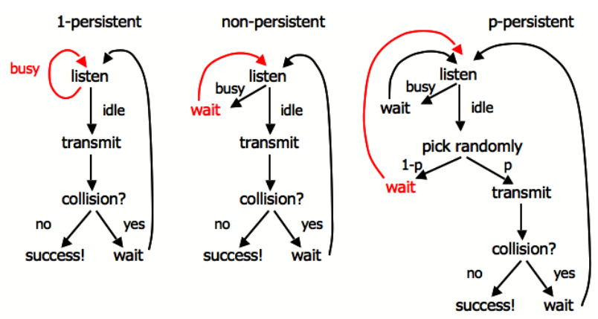

3. Collison-Free & Limited Contention Protocols (4.2.3 and 4.2.4)
Collision Free Protocols
a. Bit Map Protocol
1 bit per station overhead
Division of transmission right, and transmission event. Reservation based protocol
b. Binary Countdown Protocol
Avoid the 1 bit per station scalability problem by using binary station addressing
No collisions as higher-order bit positions are used to arbitrate
Higher numbered stations have a higher priority
ATTENTION: As soon as a station sees that a high-order bit position that is 0 in its address has been overwritten with a 1, it gives up.
c. Token Passing
Pass a small message called a token from one station to the next in the same predefined order.
In a token ring protocol, the topology of the network is used to define the order in which stations send.

COMPARISON BETWEEN CONTENTION AND COLLISION FREE
Higher loads: contention is less attractive because overhead associated with channel arbitration becomes greater
Low loads: collision free is less attractive because of a higher delay between transmissions

Limited Contention Protocols
ADVANTAGE: increase the probability of stations acquiring transmission rights by arbitrarily dividing stations and using a binary algorithm to determine rights allocation
Adaptive Tree Walk Protocol: All stations compete for right to transmit, if a collision occurs, binary division is used to resolve contention
level of tree to search first: , q is the number of competing stations

4. Wireless Protocols (4.2.5)
Two problems: Hidden terminal, Exposed terminal

MACA (Multiple Access with Collision Avoidance)
a. Send asks receiver to transmit short control frame
b. Stations near receiver hear control frame
c. Sender can then transmit data to receiver

MACAW (MACA for Wireless)

5. Classic Ethernet (4.3.2) (Discussion around Figure 4.15)
Classic Ethernet
a. Each type of Ethernet has a maximum cable length per segment
b. Multiple cable lengths can be connected by repeaters – a physical device which receives, amplifies and retransmits signals in both directions

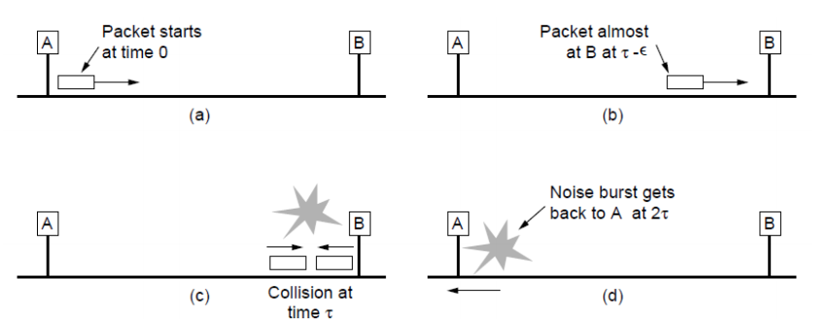
Minimum packet size problem: collisions should be detected before completing the transmission of current frame.

For a 10Mbps Ethernet, typically the worst would be nearly 50 μsec, sot 500 bits is the smallest size. This number is rounded up to 512 bits or 64 bytes for safety.

6. Practice relevant questions from Assignment 1.

Chapter 5. The Network Layer

1. Design Goals and Store and forward packet switching (5.1.1)
Design Goals
a. Services should be independent of router technologies
b. Transport layer should be shielded from number, type and topology of routers
c. Network addressing should use a uniform numbering plan

Switching: Hosts generate packets and injects into the network, Router routes packets through the network

(Dupe! Check CO & CL above) When the intermediate nodes receive a message in full before sending it on to the next node, this is called store-and-forward switching. The alternative, in which the onward transmission of a message at a node starts before it is completely received by the node, is called cut-through switching.

2. Virtual circuits (5.1.3)
If connection-oriented service is used, a path from the source router all the way to the destination router must be established before any data packets can be sent. This connection is called a VC (virtual circuit) and the network is called a virtual-circuit network.
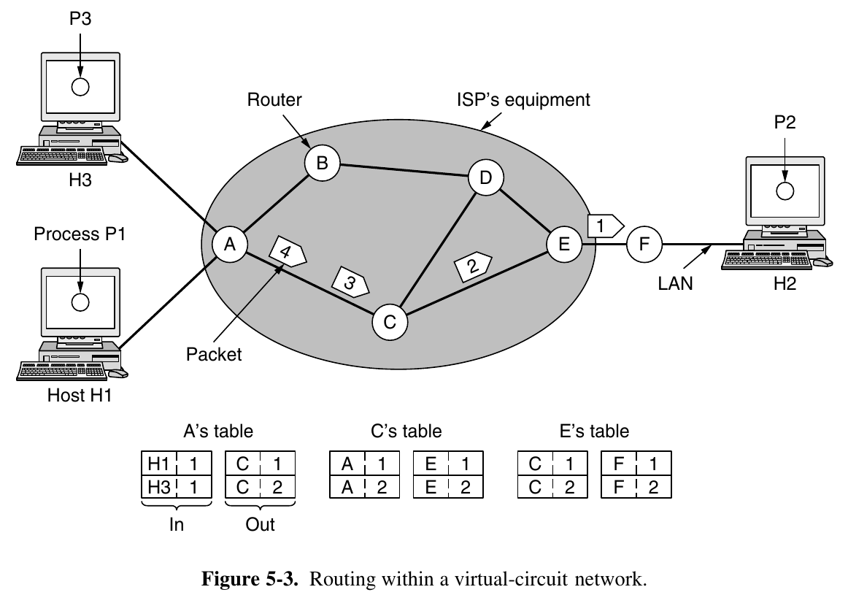
ALSO CHECK
a. How to update a routing table when new info comes in
b. Datagram routing

DIFFERENCES BETWEEN VC AND DATAGRAM
Issue | Datagram network | Virtual-Circuit network
Circuit setup | Not needed | Required
Addressing | Each packet contains the full source and destination address | Each packet contains a short VC number
State information | Routers do not hold state information about connections | Each VC requires router table space per connection
Routing | Each packet is routed independently | Route chosen when VC is set up; all packets follow it
Effect of router failures | None, except for packets lost during the crash | All VCs that passed through the failed router are terminated
Quality of Service | Difficult | Easy if enough resources can be allocated in advance for each VC
Congestion control | Difficult | Easy if enough resources can be allocated in advance for each VC

3. IP protocol and IPv4 Structure (5.6.1)
Internet Protocol
a. Provides a “best-effort” service to route datagrams from source host to destination host
b. These hosts may be: On same network, or, On different networks
c. Each network is called an Autonomous System (AS)

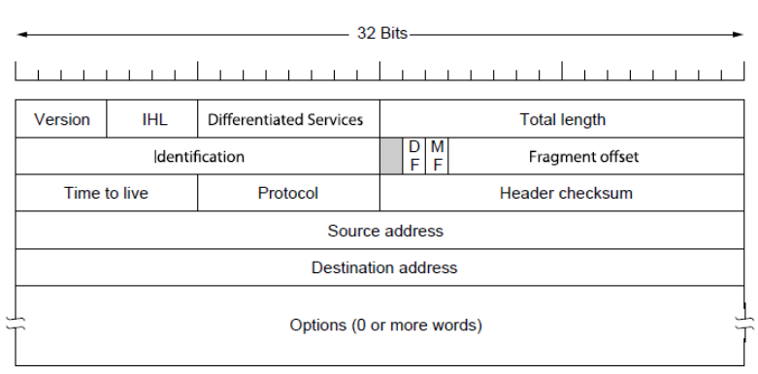

4. Addressing (5.6.1 and 5.6.2)
Classful network
Class | Leading bits | Size of network number bit field | Size of rest bit field | Number of networks | Addresses per network | Total addresses in class | Start address | End address
Class A | 0 | 8 | 24 |  |  |  | 0.0.0.0 | 127.255.255.255
Class B | 10 | 16 | 16 |  |  |  | 128.0.0.0 | 191.255.255.255
Class C | 110 | 24 | 8 |  |  |  | 192.0.0.0 | 223.255.255.255
Class D | 1110 | N/D | N/D | N/D | N/D |  | 224.0.0.0 | 239.255.255.255
Class E | 1111 | N/D | N/D | N/D | N/D |  | 240.0.0.0 | 255.255.255.255

CHECK DECIMAL IP REPRESENTATION AND CIDR
Useful link: http://www.ipaddressguide.com/cidr

Longest Matching Prefix: Packet are forwarded to the entry with the longest matching prefix or smallest address block
Appendix by Fred: It seems that routing rules in this course are always smaller the first, so we do not need to take the sequence of routing rules into consideration. (Check tutorial W6Q9.)

